Gauntlet of Ruin

# Summary

Genre: Action Platformer

Gauntlet of Ruin is a 2D Action Platformer in which the player aims to complete the levels as fast as possible in order to compete with other players with their time. The players have multiple tools to assist them in their task, namely the ability to control the four basic elements: Wind, Fire, Earth and Water. Players start off with all abilities, but will be presented with different challenges and ways to use them throughout the game. The focal point is speed, and creativity.

## Target Audience

**Demographics**

Age: 7-32

Gender:    Inclusive

Location: Inclusive

Genres: Action, Platformer, Metroidvania

**Psychographics**

Personality:  Thrill-seeking

Attitudes: Stubborn, Daring

Values:     Improvement

Lifestyles: Inclusive

Behaviour:  Ambitious, Precis

## Goals

### External Goals

* Be a platform for level design
* Allow me to work further on my 2D development skills
* Be a passion project that can be worked on further even after deadline submission.
* Begin and grow familiar with Godot

### Internal Goals

Solve problems through varying means

* Move fluidly through the level.
* Replayability through achieving a faster time is encouraged.

## Narrative Design

### Player: Receiver

The player receives the story as it is written. They have no influence over it during the game through short and simple cutscenes. Interactions with the environment are conveyed through gameplay.

### Story Type: Linear, Fully Traditional

As the player is a Receiver, and the story takes a backseat during this game, the type is linear and traditional. There are no differences in the story based on the player’s actions, and the only time the story takes a focus is during the beginning and end of levels. The player finds themselves at the bottom of a tomb, just having found the treasure at the bottom: The Gauntlet of Four Elements. Though upon picking it up, the entrance closes and forces them to leave the tomb through an unfamiliar path before everything collapses! Will they be able to escape before the tomb collapses onto them?

### NPC Behaviour:

Every NPC in the game is hostile, and will attack the player on sight. The enemies’ design and attack patterns vary based on the current zone (i.e. enemies in the fire portion of the temple throw fire at the player, while enemies at the beginning will have much simpler attacks that are easier to avoid.)

## Design Requirements

### Functional Requirements

* The game should allow players to freely move through the map.
* The player should be able to keep track of their character at all times
* The player should be able to switch between elements
* The player should be able to defeat enemies in the world
* The player should be able to accelerate themselves through use of their abilities
* The enemies should be able to recognize the position of the player and attack them accordingly
* The environment should be able to interact with the player, and vice versa

### Usability Requirements

* Users should be informed of which element is currently selected through multiple means
* Users should be taught the core mechanics early into the game
* Users should be able to quickly replay levels once completed
* Users should be able to view the time spent in the current level
* Users should be able to view a leaderboard of the fastest times to complete the level
* Users should be ask to confirm to leave the game
* Users should easily be able to tell the way forward

### User Experience Requirements

* Users should feel the movement is fluid and intuitive
* Users should feel that they are always able to improve their time
* Users should feel encouraged to explore different ways of completing the level
* Users should be able to adjust the game to their own needs by virtue of changing graphic and audio settings
* Users should feel inspired to compete with friends and other players on the global leaderboard

# Game Elements

## Story

Our protagonist, Aibo, finds themselves at the bottom of a tomb, having just discovered its treasure- the Gauntlet of Four Elements. Though picking it up seems to have put him in a pickle. The way in locks behind him, and instead a new way out is revealed. He had previously scouted the Tomb, but had only brought enough equipment to get to the bottom. Thankfully, the artefact is not without its benefits. Using his newfound powers, Aibo needs to explore the newly opened half of this tomb, uncover its secrets, and escape!

During his journey, he will encounter different kinds of enemies and challenges not too different to the very powers he himself is using. He will also have to face off against the curse of the Tomb. If he doesn’t move fast enough, he will fall to it.

If the player chooses to spend the time, they may also discover hidden tidbits about the ancient civilization that used to guard this Gauntlet, and their tragic fall from grace. Not a single history book Aibo has seen has any mentions of them, but someone must have built this temple, and created the gauntlet…

## Level Design

The first level of the game is built much more linearly than the rest would be, as it is a tutorial level meant to introduce the player to the mechanics. There are several moments where the player is forced to continue forwards using a specific method, which usually goes against the goal of the game, however felt necessary when introducing the players to the mechanics, as having it be possible to skip through the tutorial without having to use all of them could result in a small number of players never using one, or more of their abilities. Below is an annotated map of the level, split in two due to the size.

The player begins from the bottom left of the map, having just left the introductory cutscene, and is gradually forced to play around with all of their powers as they reach the end of the map.

# Gameplay

## Overview

Core Gameplay

* Change between elements to use your different abilities
* Use different abilities to aim for a faster completion time
* Interact with the environment through use of your abilities

Elements

* Wind: A rapid dash which propels the main character towards the direction of the mouse (More effective when aiming upwards)
* Fire: A ball of fire that kills most enemies and destroys weaker walls
* Water: A spray of water that pushes back enemies, extinguishes fires, and pushes the main character backwards
* Earth: Conjure a rock that the main character can stand on, allowing them to reach further, block off enemies or projectiles, and, if positioned correctly, jump a second time in the air

Interactions

* Enemies
* Environment: Lava, water, breakable walls, Temporary Platforms

Restrictions

* Player Health Points
* Time Limit

### Objectives

* Escape: The player’s main objective is to escape the Tomb
* Time Pressure: The player must complete the level before the timer runs out
* Competition: The player may choose to compete for the fastest time to complete a level

# Mechanics

## Controls

|  |  |  |
| --- | --- | --- |
| Action | Primary | Secondary |
| Run | W/A | Arrow Keys |
| Switch Elements | Q/E | Arrow Keys Up and Down |
| Use Element | Right Click | X |
| Jump | Spacebar | X |

## Gameplay Loop

The gameplay loop follows a linear structure in which the player either wins or loses. The intended user experience is to encourage the player to replay the levels and improve at them to aim for a faster time. To hammer in this playstyle, players are both shown their own time and are compared to the global leaderboard once the level is complete.

## Known Issues

* Bug: If the player conjures a rock on top of their head, there is a high likelihood that the rock becomes stuck on their head, preventing them from jumping
* Bug: The door to exit the battle arena cannot differentiate between mobs killed in the arena and mobs killed before it and has been replaced with a breakable wall temporarily
* Bug: If the mouse is positioned precisely enough, the player can infinitely jump onto their conjured rock, then respawn it, then jump again.

## Theme and Mood

The theme of the levels switches quite often, all of them, except the first one, being based on the four elements that the player can control, though several things remain constant: There should always be the underlying theme of mystery and a feeling of being in an old, abandoned place. And each level is to remain firmly within the theme of its assigned element.

### Mood

The intended mood that the game conveys to the player is a feeling of being rushed. Much like Indiana Jones escaping a boulder once he takes the treasure, the player is incentivized to throw caution to the wind and speed through the Tomb as fast as possible. The different styles of levels should shift the mood to appropriately communicate the danger and expected length of the level that the player is on, as mentioned in the beat chart. In example, the Flooded Ruins should balance a level of danger with a level of calmness to keep the player going fast while also conveying that the level is supposed to be slower than the rest.

## Future Improvements

Below is a list of features that would be included in a final release of the game:

* Create sub-levels for each area, allowing the game to explore the area’s themes further
* Make it so that the fire and water projectiles follow the mouse cursor, rather than extend forwards from the character
* Change the water projectile into a stream that pushes the character backwards, allowing for more styles of movement
* Deepen the use of the Earth element
* Improve enemy AI and create more variations of it
* Introduce element combinations in future levels, allowing for the player to unlock more abilities as they progress
* Introduce the global leaderboard spoken about earlier in the document
* Style the UI to fit the temple/tomb aesthetic, have it change theme based on the current area
* Introduce bosses as final levels of each area
* Environment and Enemy assets that fit the different areas
* Improved asset for the main character
* More variety in the tile set
* Rewards for scoring a good time
* Introduce skills for the main character reflecting their role as a professional tomb raider (i.e., a grappling hook)
* Change the main character model to reflect the currently selected element for the player to have an easier time reading which mode they have currently selected.

## Iterations

* The game was first imagined as a slower pace game much more focused on a metroidvania kind of style of platforming.
* Initial Annotated map:

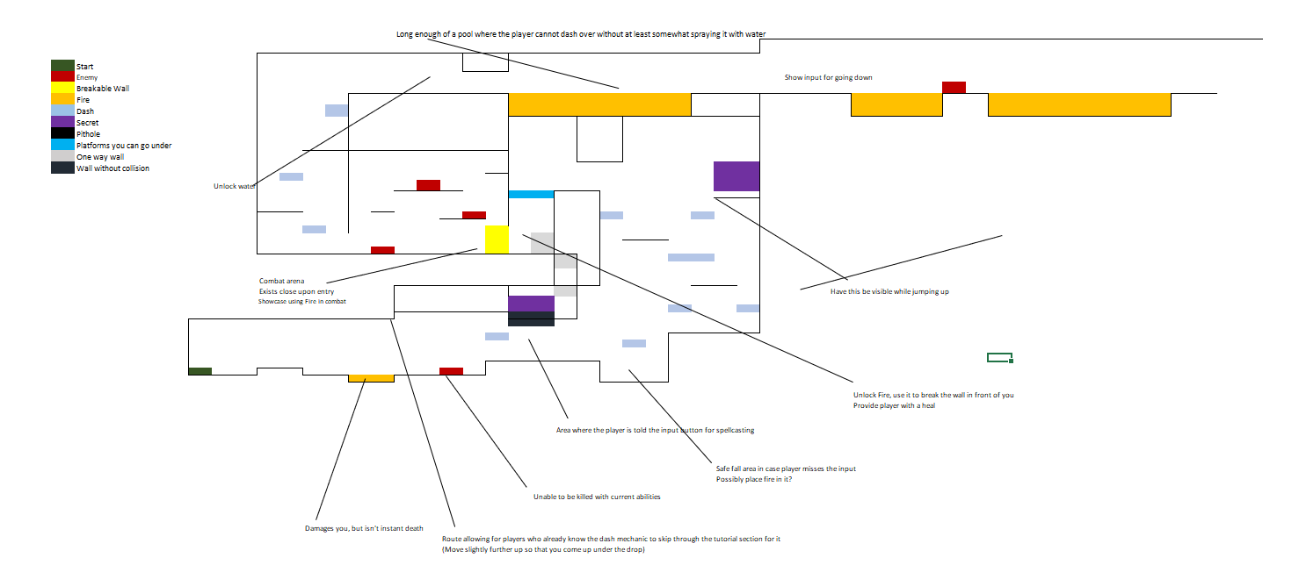

Ultimately, most of the initial draft remained, however the lava was exchanged for a much less complex fire. As well as that, more enemies have been placed around the map so that there are less dead zones.

## Assets and Art Conventions

The art direction is supposed to be a simple, pixel-art style. Referencing games such as “Dead Cells” and “Noita”. Reserved use of particle effects, mainly floating around the player. Most of the environments are well lit up so as to not deprive the player of information, though the assets used may imply a darkness in the in-game environment itself. As the timer goes lower, a vignette post-processing effect may appear on the screen, further hammering down the time pressure onto the player. Ultimately, the goal of the art and assets is to create a clutter-free environment that also aims to put pressure onto the player.

## References

### Tutorials

freeCodeCamp.org. (2023, April 18). *Godot Game Development – Crash Course for Beginners*. Www.youtube.com. https://www.youtube.com/watch?v=S8lMTwSRoRg&ab_channel=freeCodeCamp.org

### Assets

ansimuz. (2017, May 30). *Sunny Land - Pixel Game Art by ansimuz*. Itch.io. https://ansimuz.itch.io/sunny-land-pixel-game-art

brullov. (2019, December 5). *Fire Animation - Pixel Art FX Sprites 🔥 by brullov*. Itch.io. https://brullov.itch.io/fire-animation

elska. (2020, October 23). *Water Bending Magic (Free 2D Pixel) by Elska*. Itch.io. https://elska.itch.io/water-bending-magic